DATABASE QUESTIONS AND ANSWERS:

1.

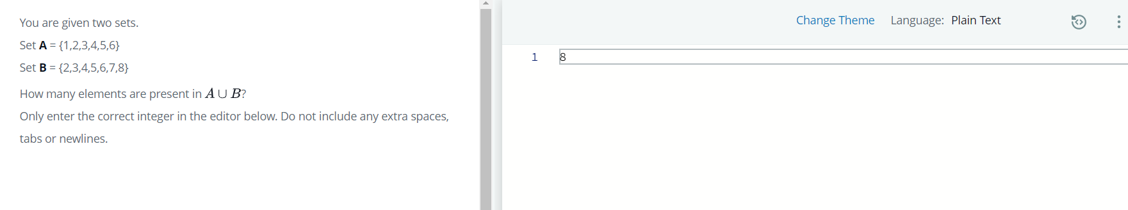

2.

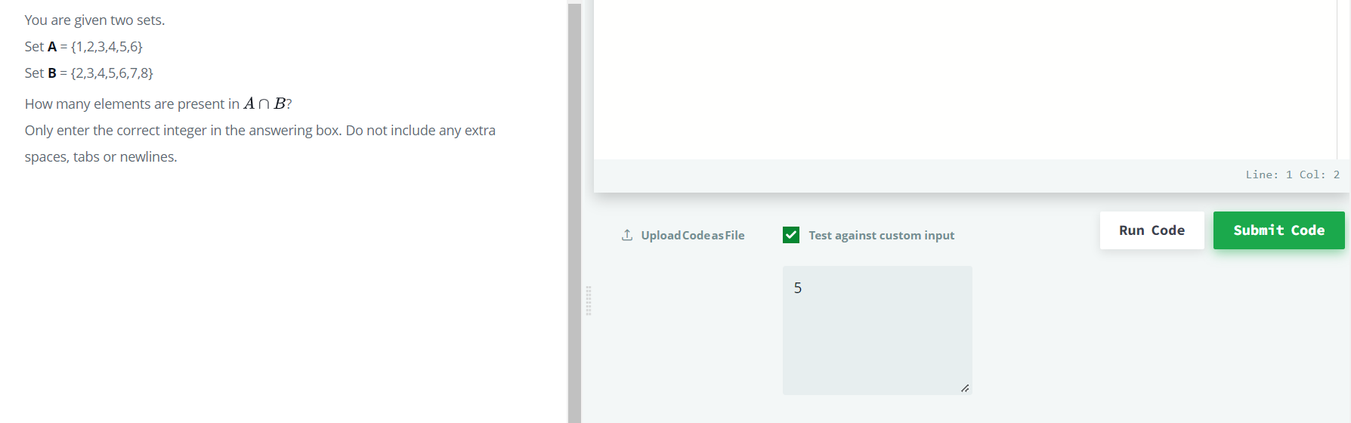

3.

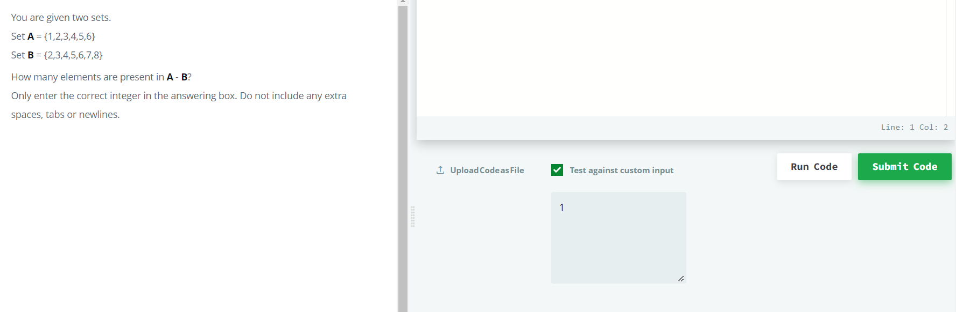

4.

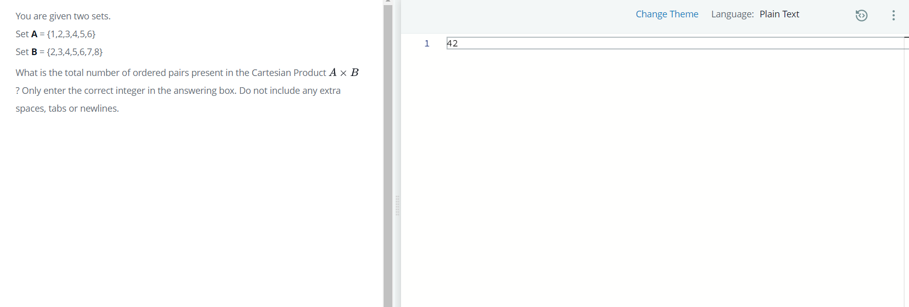

5.

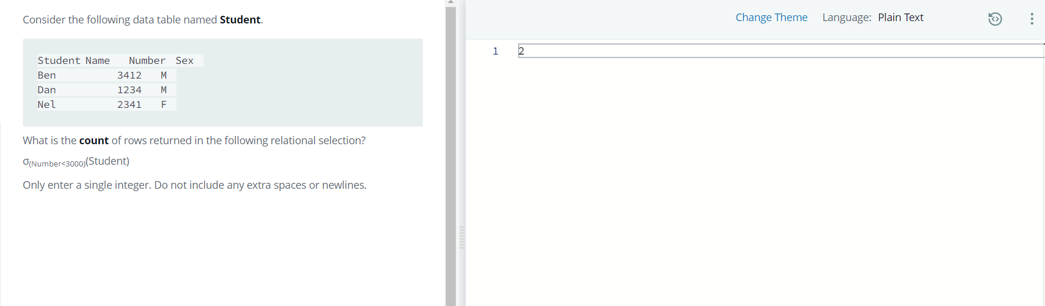

6.

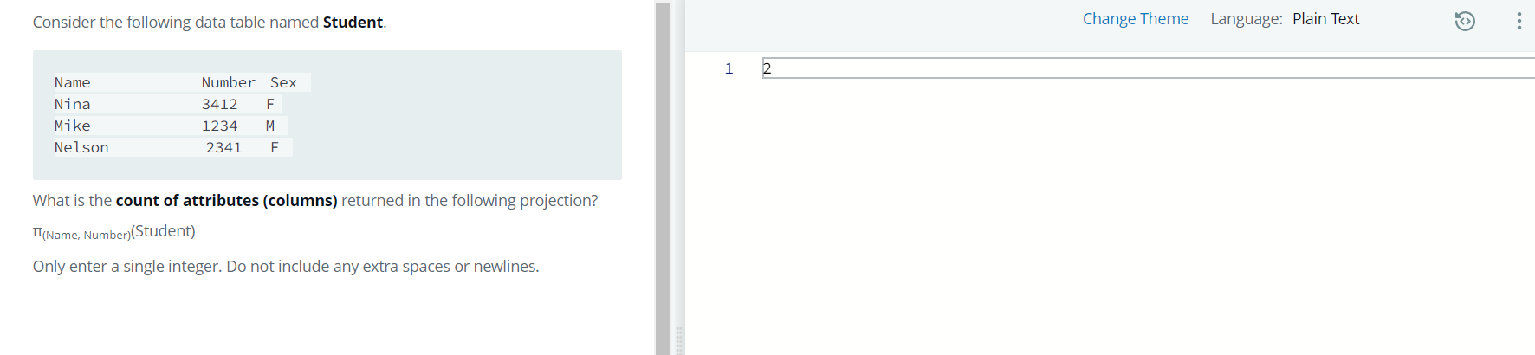

7.

